# Lorem Picsum

## The Lorem Ipsum for photos.



[](https://srv.carbonads.net/ads/click/x/GTND42Q7F67ICK3NF6BLYKQMF6AIV23JC67D6Z3JCWAIL23UC67IKKJKCYYIE2JMCVSDEKQICY7I62Q7F6SDT23KC6BIL5QIC6ADTK3EHJNCLSIZ?segment=placement:picsumphotos;)[Limited time offer: Get 10 free Adobe Stock images.](https://srv.carbonads.net/ads/click/x/GTND42Q7F67ICK3NF6BLYKQMF6AIV23JC67D6Z3JCWAIL23UC67IKKJKCYYIE2JMCVSDEKQICY7I62Q7F6SDT23KC6BIL5QIC6ADTK3EHJNCLSIZ?segment=placement:picsumphotos;)[**ADS VIA CARBON**](http://carbonads.net/?utm_source=picsumphotos&utm_medium=ad_via_link&utm_campaign=in_unit&utm_term=carbon)

## Easy to use, stylish placeholders

Just add your desired image size (width & height) after our URL, and you'll get a random image.

<https://picsum.photos/200/300>

To get a square image, just add the size.

<https://picsum.photos/200>

## Specific Image

Get a specific image by adding /id/{image} to the start of the url.

<https://picsum.photos/id/237/200/300>

You can find a list of all the images [here.](https://picsum.photos/images)



## Static Random Image

Get the same random image every time based on a seed, by adding /seed/{seed} to the start of the url.

<https://picsum.photos/seed/picsum/200/300>



## Grayscale

Get a grayscale image by appending ?grayscale to the end of the url.

<https://picsum.photos/200/300?grayscale>

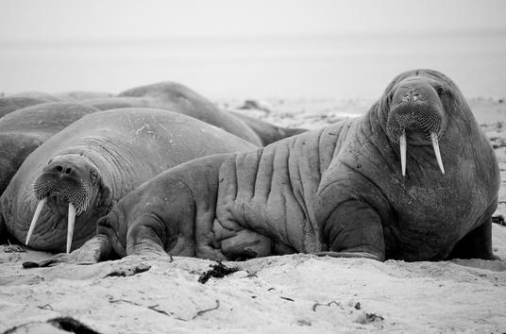

## Blur

Get a blurred image by appending ?blur to the end of the url.

<https://picsum.photos/200/300/?blur>

You can adjust the amount of blur by providing a number between 1 and 10.

<https://picsum.photos/200/300/?blur=2>



## Advanced Usage

You may combine any of the options above.

For example, to get a specific image that is grayscale and blurred.

<https://picsum.photos/id/870/200/300?grayscale&blur=2>

To request multiple images of the same size in your browser, add the random query param to prevent the images from being cached:

<img src="https://picsum.photos/200/300?random=1">

<img src="https://picsum.photos/200/300?random=2">

If you need a file ending, you can add .jpg to the end of the url.

<https://picsum.photos/200/300.jpg>

To get an image in the WebP format, you can add .webp to the end of the url.

<https://picsum.photos/200/300.webp>

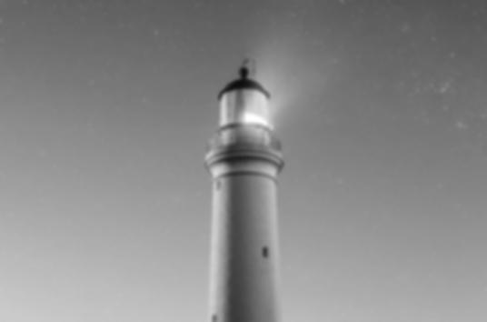

## List Images

Get a list of images by using the /v2/list endpoint.

<https://picsum.photos/v2/list>

The API will return 30 items per page by default.

To request another page, use the ?page parameter.

To change the amount of items per page, use the ?limit parameter.

<https://picsum.photos/v2/list?page=2&limit=100>

The Link header includes pagination information about the next/previous pages

[

{

"id": "0",

"author": "Alejandro Escamilla",

"width": 5616,

"height": 3744,

"url": "https://unsplash.com/...",

"download_url": "https://picsum.photos/..."

}

]